

**Candidate Information Pack**

Early Years Class Teacher (Maternity Cover)

**Contents**

|  |  |
| --- | --- |
| About the Trust | 1 |
| About us | 2 |
| Our vision and values | 3 |
| Working at Rainbow Forge Primary Academy | 4 |
| Benefits of being part of L.E.A.D. Academy Trust | 5 |
| How to apply | 6 |
| Job description and Person specification | 7 |

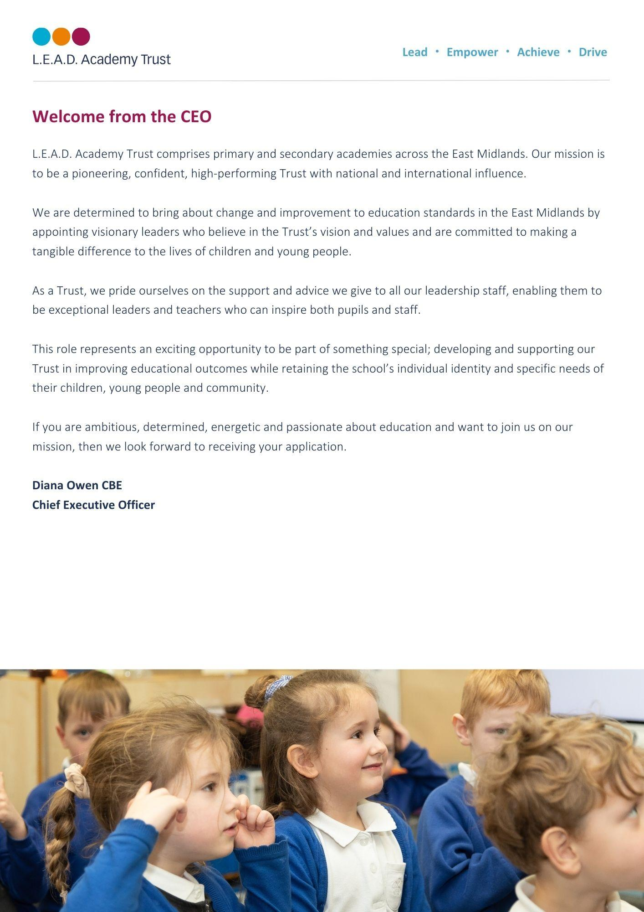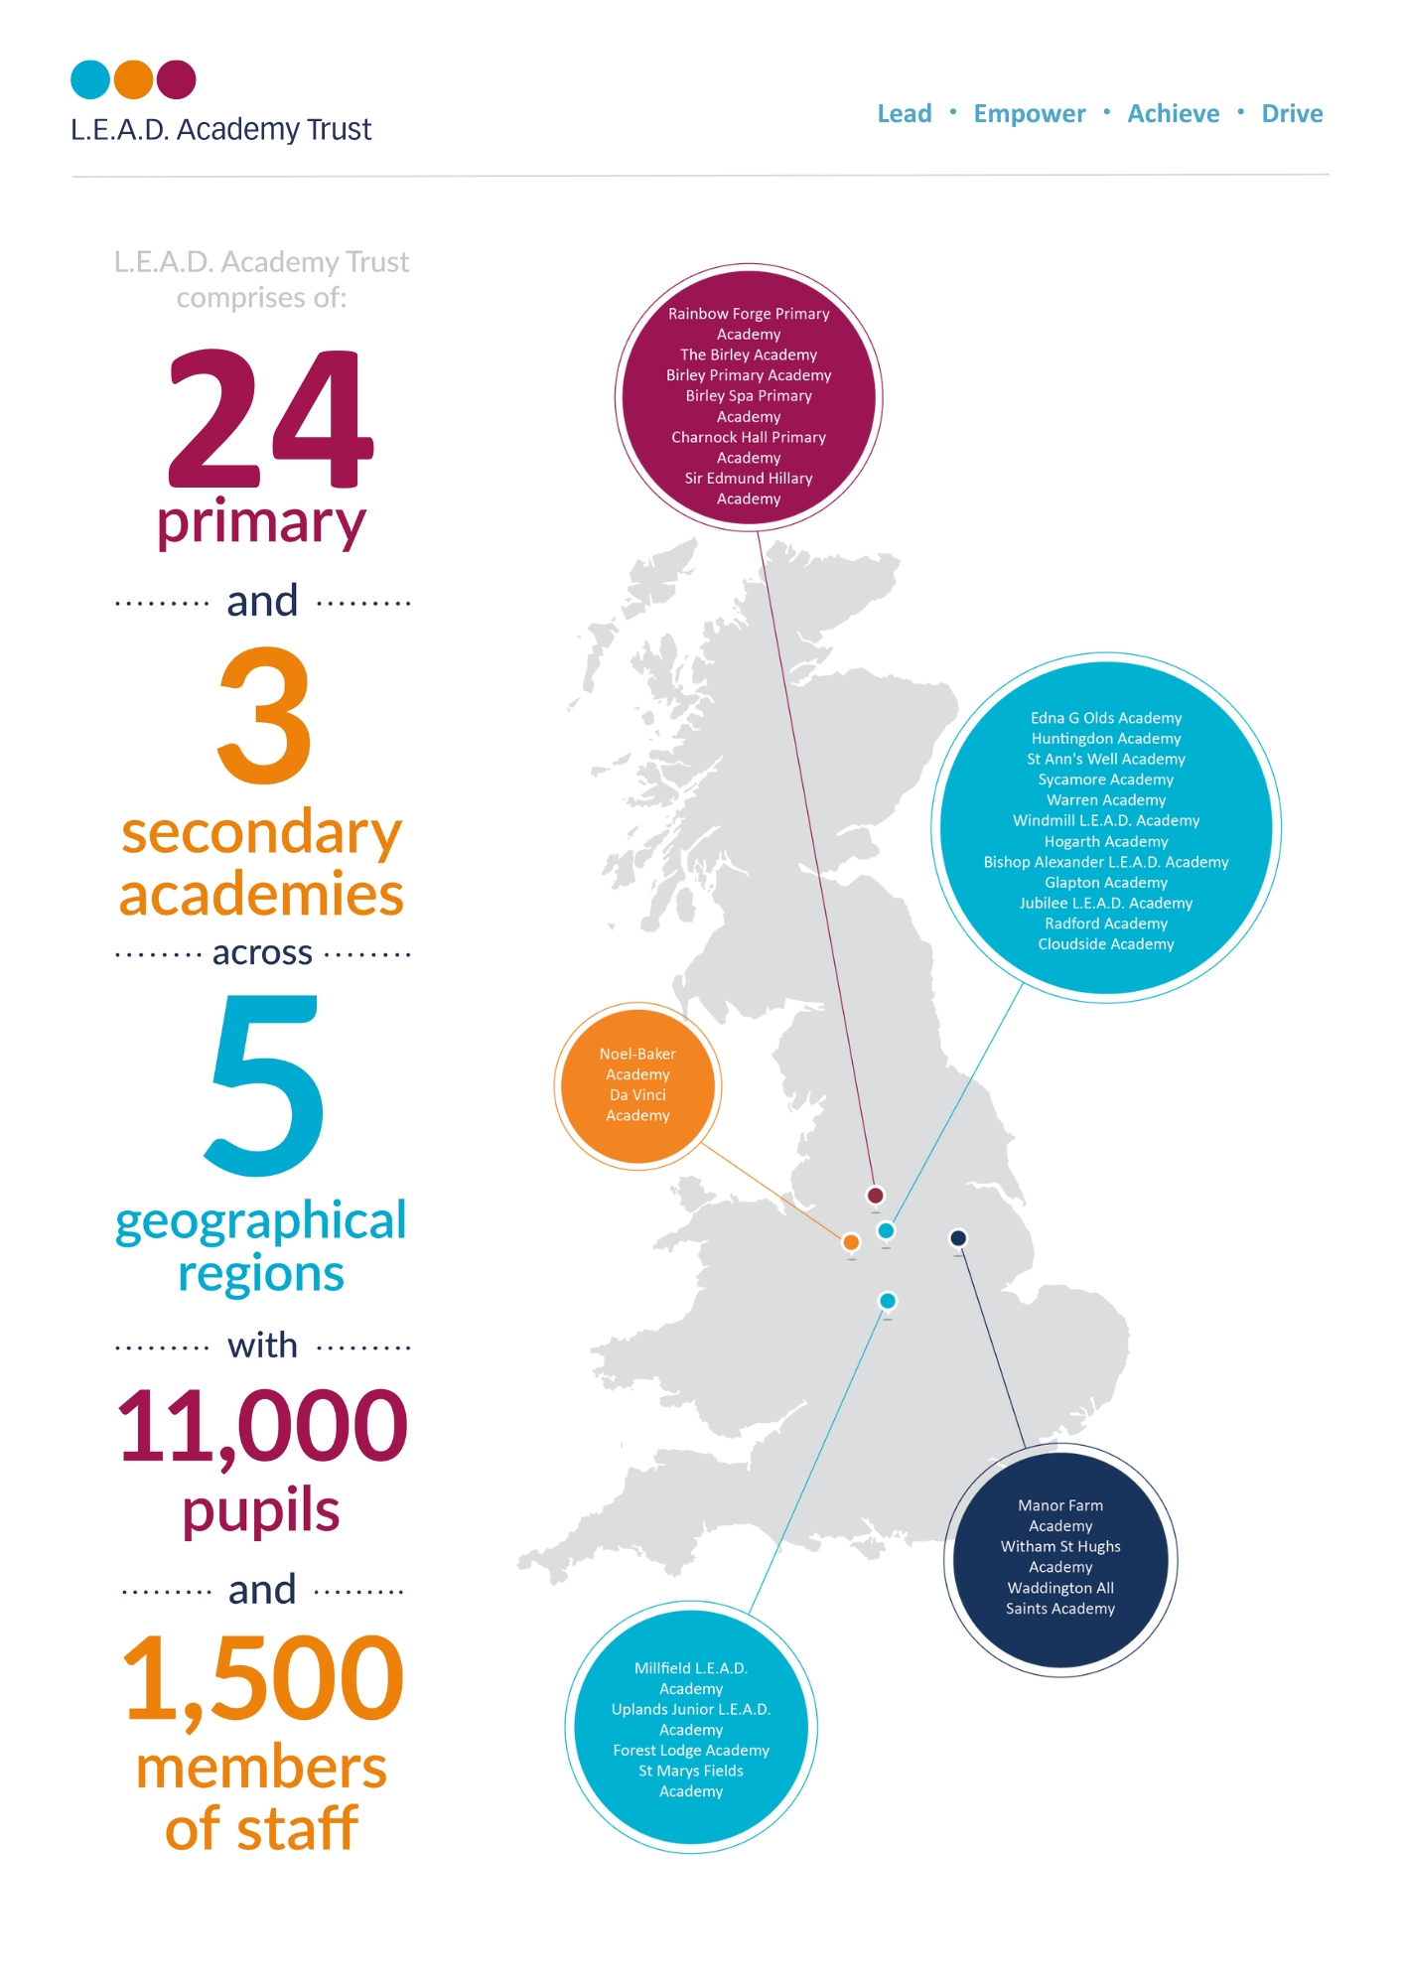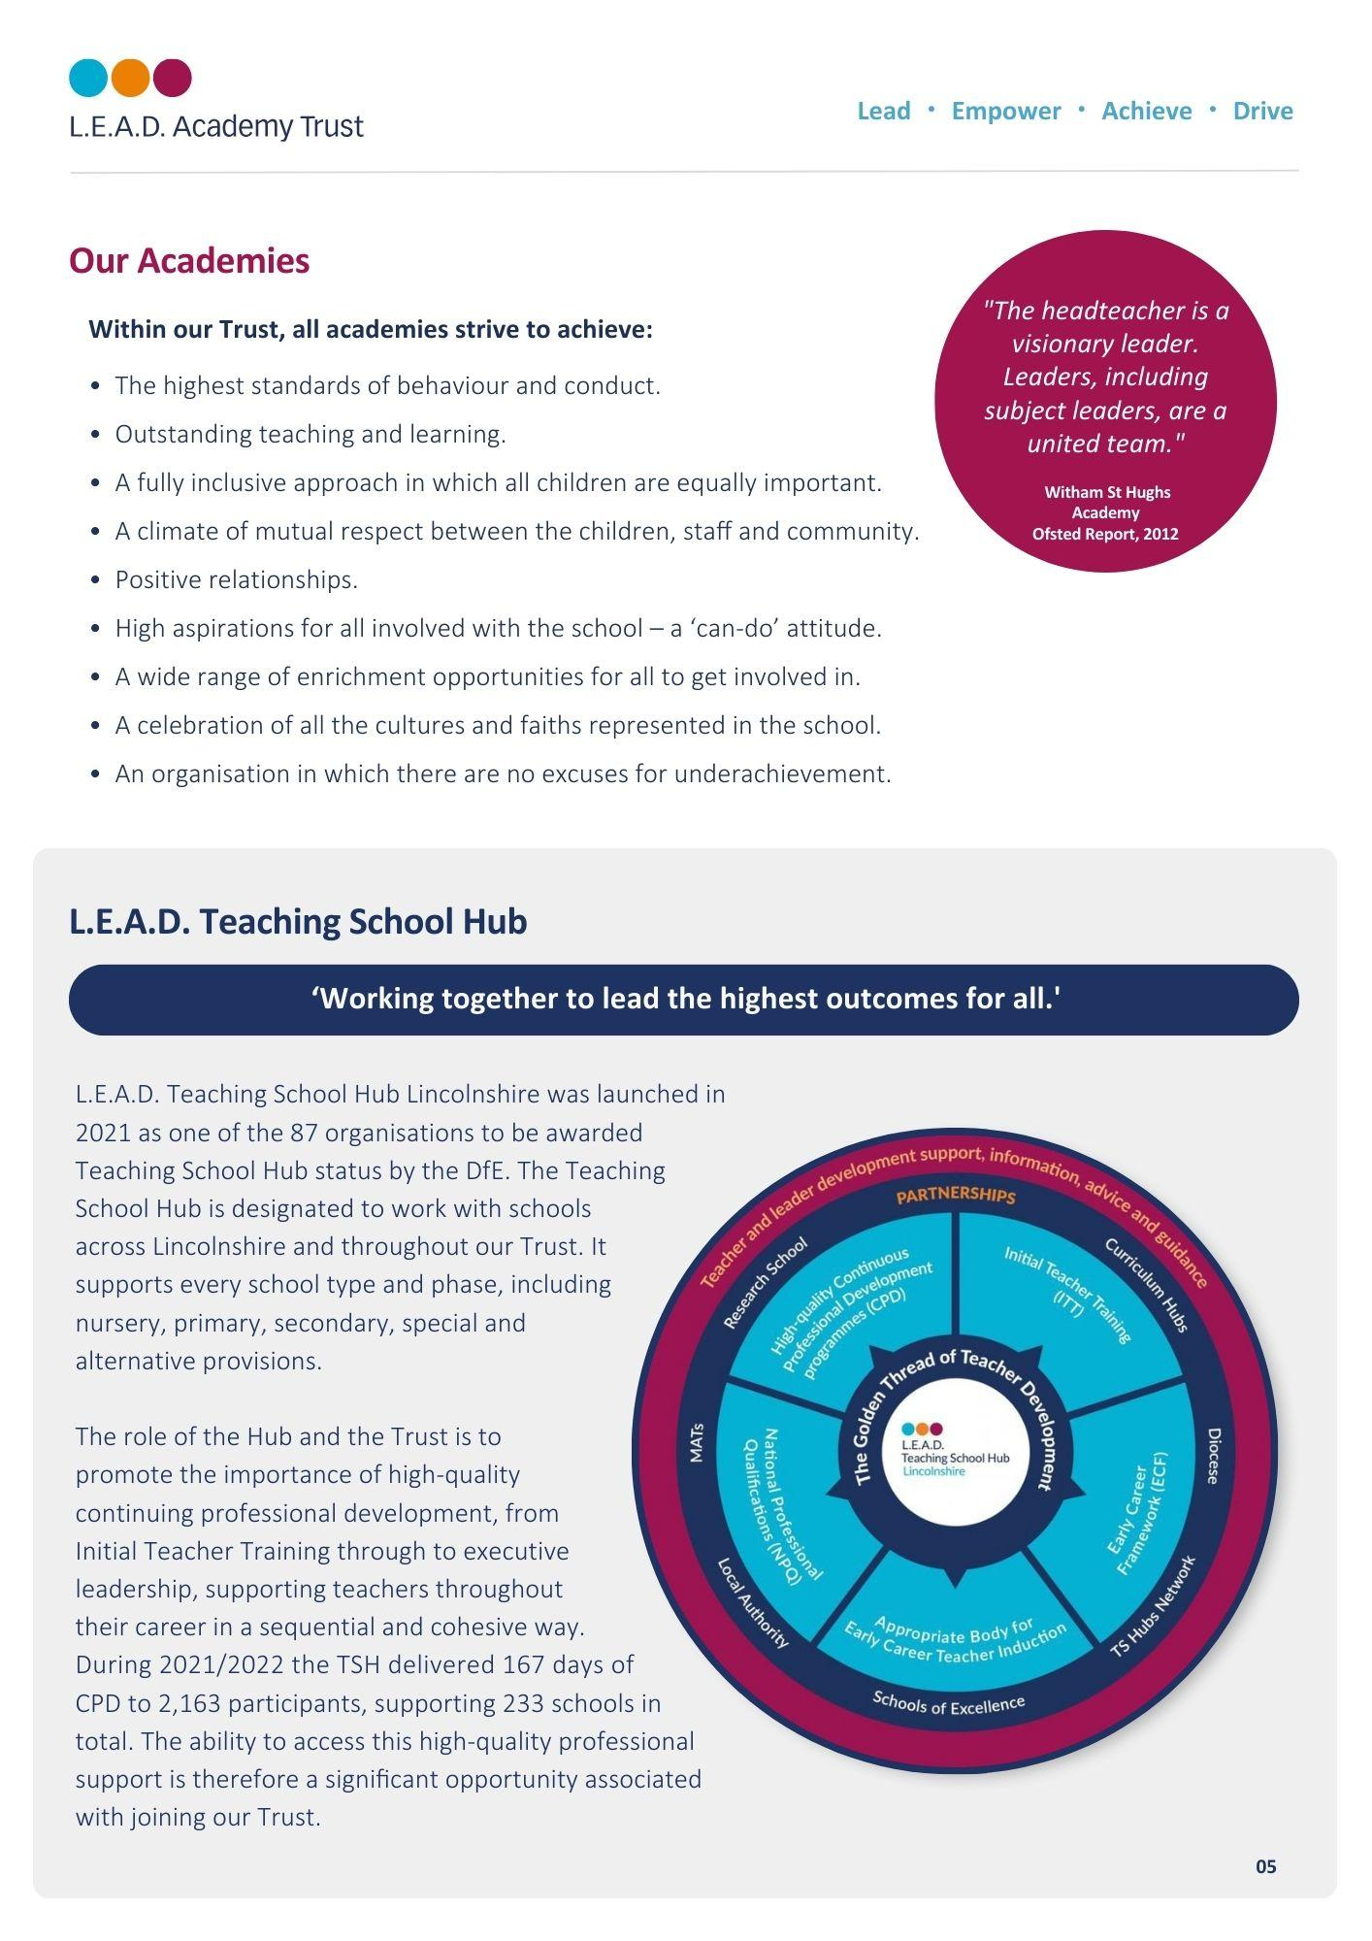

**A message from the Headteacher**

**Message from the Headteacher**

I am very proud to be the Headteacher at Rainbow Forge Academy and feel privileged to work with our pupils, parents, cares, colleagues and community to be part of the team making Rainbow a fabulous place to learn and work.

I am passionate about creating inclusive classrooms, nurturing the whole-child and working with staff both in school and with colleagues across L.E.A.D Academy Trust to ensure the highest quality education, supporting a love of lifelong learning and where everyone can grow and flourish.

**Roberta Reilly** 

**About Rainbow Forge Primary Academy**

At our Ofsted rated GOOD school, children can begin their journey with us from the age of two and we support our working families by providing wrap around care through breakfast and after school clubs run by our own highly trained, passionate staff.

At Rainbow we pride ourselves on having the very highest of standards of behaviour and attitudes to learning. Our children are our strength, they are proud of their school and enjoy taking an active role within the school community. On visiting Rainbow, you will see happy, friendly children who are eager to learn.

It is our aim to provide our children with the best knowledge available to ensure that they are ready for the next stage of their education.

We are developing a curriculum that ensures the children have a positive attitude to learning and develop the academy values of being Respectful, Honest, Brave, Determined, Kind and Caring.

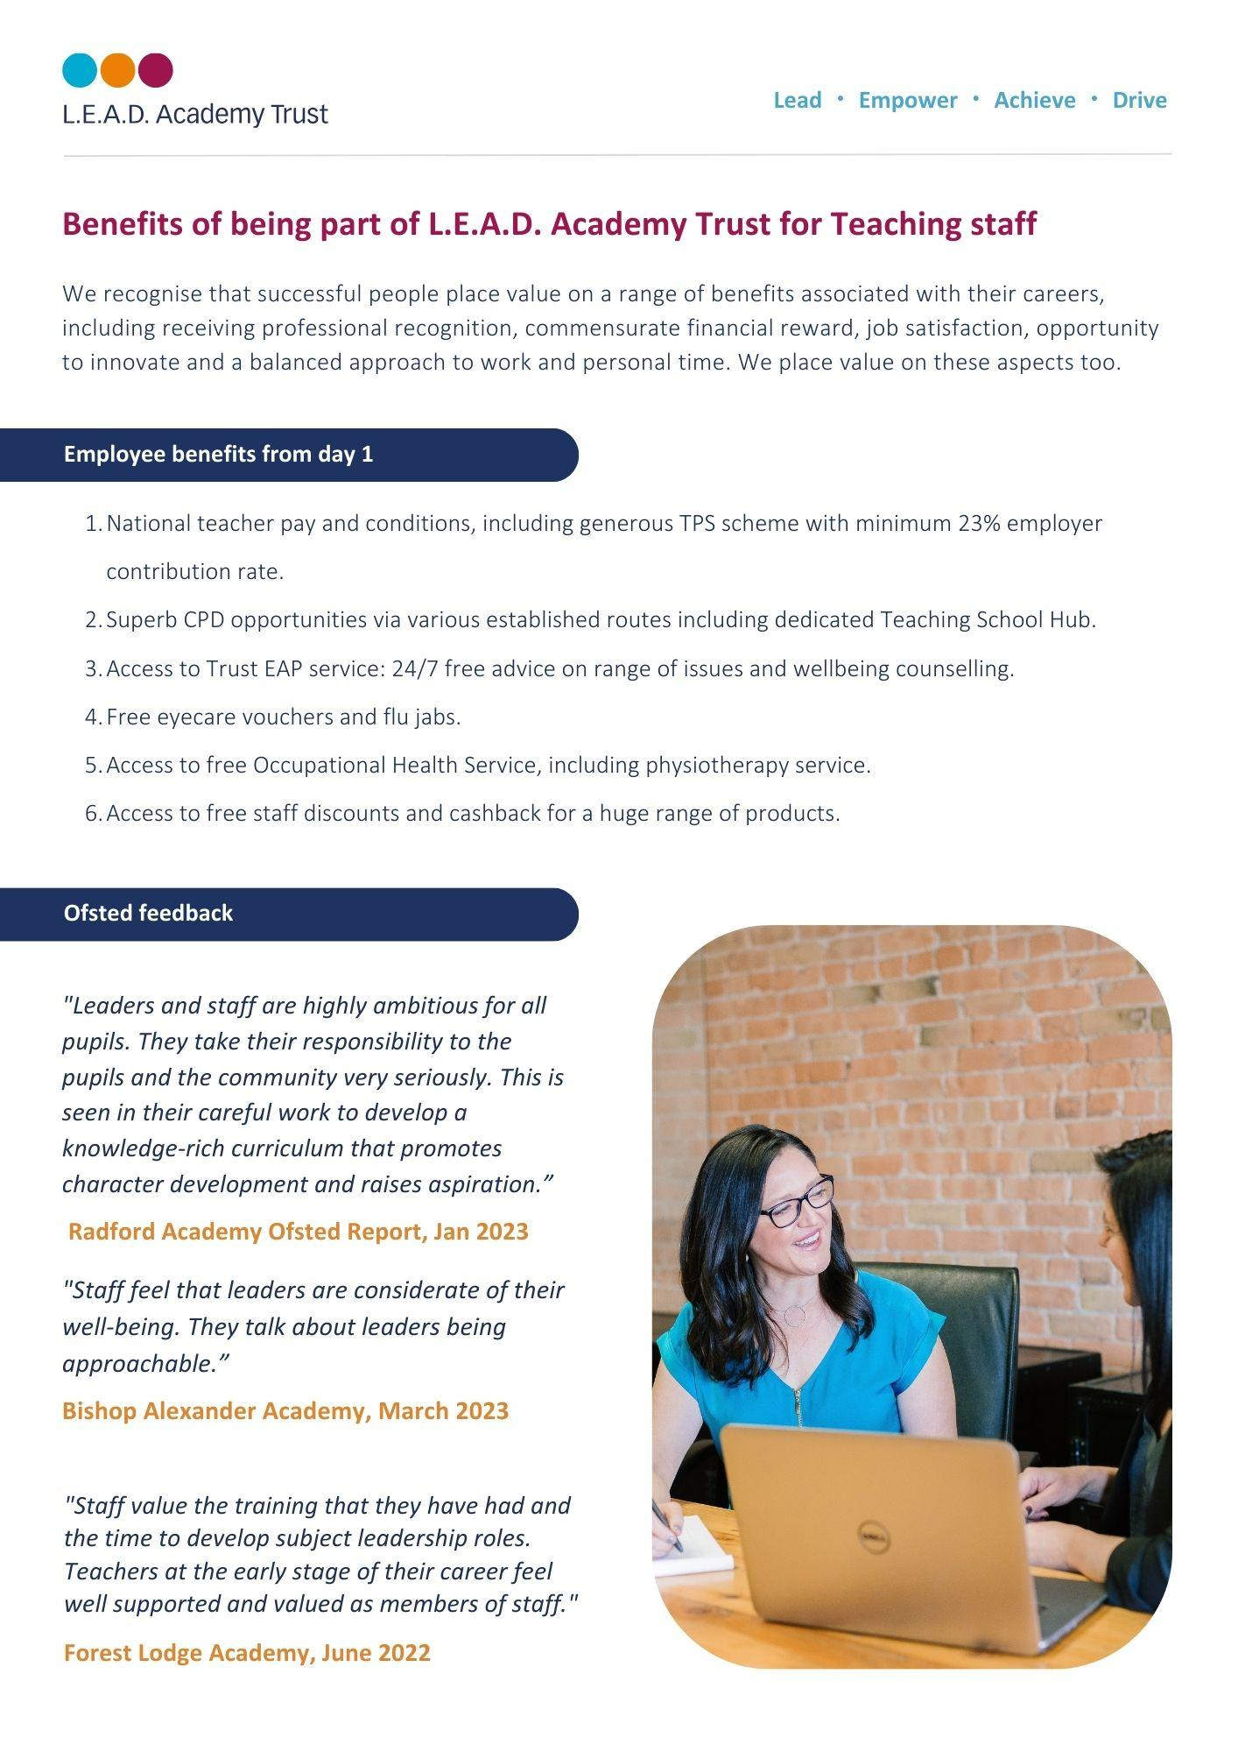

Pupils behave well in lessons and at social times. Pupils know the school rules and respond well to them. As a result, pupils enjoy their lessons- OFSTED Dec 2023

**How to apply**

Please send a completed application form and covering letter explaining your interest in the role and how you meet the person specification to: **bethanyjames@rainbowforgeacademy.co.uk**

**CLOSING DATE**: Tuesday 5th November

**INTERVIEWS**: We expect interviews to take place **on Thursday 14th November**

Applications will be reviewed upon receipt, therefore shortlisted candidates may be contacted in advance of the closing date.

L.E.A.D. Academy Trust is committed to safeguarding and promoting the welfare of children and young people and we can expect all staff and volunteers to share this commitment. This post is subject to an enhanced DBS check.

For an informal, confidential discussion about this opportunity, please email: **bethanyjames@rainbowforgeacademy.co.uk**

  
  
  
  
  
  
  
  
  
  
  
  
  
  
  
  
  
  
  


**Job description**

**Key responsibilities and accountabilities**

**Class Teacher**

**Salary: Main Payscale**

* To exemplify excellent classroom practice that results in high standards of learning and achievement for the pupils/students in your care.
* To support the Senior Leadership Team in establishing a culture that promotes excellence, equality and high expectations of all pupils/students and the L.E.A.D. Trust values.
* To ensure that your professional practice is informed by rigorous self-evaluation and that it continuously improves learning and pastoral outcomes.
* To ensure that you provide a safe and happy environment that promotes the welfare of children.
* Understand how a range of factors can inhibit pupils/students’ ability to learn, apply this understanding to overcome these restrictions to learning.
* Demonstrate an awareness of the physical, social and intellectual development of children, and know how to adapt teaching to support pupils/students’ education at different stages.
* Have a clear understanding of the needs of all pupils/students, including those with special educational needs; those of high ability; those with English as an additional language; those with disabilities; and be able to use and evaluate distinctive teaching approaches to engage and support them.

**Main Responsibilities:**

**Make accurate and productive use of assessment**

* Know and understand how to assess the relevant subject and curriculum areas, including statutory assessment requirements.
* Make use of formative and summative assessment to secure pupils/students’ progress.
* Use relevant data to monitor progress, set targets, and plan subsequent lessons.
* Give pupils/students regular feedback, both orally and through accurate marking, and encourage pupils/students to respond to the feedback.

**Behaviour and safety and Personal Development**

* Manage behaviour effectively to ensure a purposeful, stimulating and safe learning environment.
* Have clear rules and routines for behaviour in classrooms, and take responsibility for promoting good and courteous behaviour both in classrooms and around the site, in accordance with the academy’s behaviour policy.
* Have high expectations of behaviour, and establish a framework for discipline with a range of strategies, using praise, sanctions and rewards consistently and fairly.
* Manage classes effectively, using approaches which are appropriate to pupils/students’ needs in order to involve and motivate them.
* Maintain good relationships with pupils/students, exercise appropriate authority, and act decisively when necessary.
* Carry out playground/bus and other duties as directed and within the remit of the current School teachers’ pay and Conditions Document.
* Promote and safeguard the welfare of children and young people within the academy, raising any concerns by following the academy safeguarding policies and procedures.
* Promote British values, equalities and pupils’/students’ spiritual, moral, social and cultural development.

**Fulfil wider professional responsibilities**

* Make a positive contribution to the wider life and ethos of the academy.
* Develop effective and collaborative professional relationships with colleagues, drawing appropriately on advice and specialist support.
* Deploy support staff effectively.
* Ensure that parents/carers and pupils/students are well informed about the curriculum, attainment and progress and about the contribution they can make in supporting their child’s learning and wellbeing.
* Provide the senior leadership team on request accurate, timely and coherent information about class, group or individual pupil/student progress and attainment in order to inform regular academy development planning.
* Carry out any such duties as may be reasonably required by the Headteacher.

**Team working and collaboration**

* Participate in any relevant meetings/professional development opportunities which relate to the learners, curriculum or organisation of the academy including pastoral arrangements and assemblies.
* Work as a team member and identify opportunities for working with colleagues and sharing the development of effective practice with them.
* Contribute to the selection and professional development of other teachers and support staff including the induction and assessment of new teachers, teachers serving induction periods and where appropriate threshold assessments.
* Ensure that colleagues working with you are appropriately involved in supporting learning and understand the roles they are expected to fulfil.
* Take part as required in the review, development and management of the activities relating to the curriculum, organisation and pastoral functions of the academy.
* Cover for absent colleagues within the remit of the current School Teachers’ Pay and Conditions document.

**Administration**

* Register the attendance of and supervise learners, before, during or after sessions as appropriate.
* Participate in and carry out any administrative and organisational tasks within the remit of the current School Teachers’ Pay and Conditions Document.

**Professional development**

* Regularly review the effectiveness of your teaching and assessment procedures and its impact on pupils’ progress, attainment and wellbeing, refining your approaches where necessary and responding to advice and feedback from colleagues.
* Be responsible for improving your teaching through participating fully in training and development opportunities identified by the school or as developed as an outcome of your performance management.

**Resource Management:**

* Responsibility for the safe use and safe keeping of Academy and Trust resources in line with the requirements of the role.

**Influencing and Managing Relationships:**

* Required to have positive working relationships with The Headteacher and Senior Leadership Team within the Academy and all other Trust schools as required.
* Positive working relationships with teaching and support staff, parents and other third party organisations as required.



**Person specification**

The person specification listed below outlines the competences, knowledge and behaviour of candidates who would be suitable for this role. The two right-hand columns provide guidance as to whether these items are essential (E) or desirable (D) criteria.

This job description lists the competencies expected of an experienced/fully trained post-holder. The two right hand columns provide guidance for the appointment of new staff. (E = Essential criteria, D + Desirable criteria)

|  |  |  |  |
| --- | --- | --- | --- |
|  | | **E** | **D** |
| **Qualifications and Attainments** | * Qualified teacher with QTS or recognised equivalent * Teaching experience within the age range and/or subjects applying for (NQT status may also be relevant) | E  E |  |
| **Skills and**  **knowledge** | * Ability to create a stimulating and safe learning environment. * Ability to establish and maintain a purposeful working atmosphere * Ability to plans, prepare and deliver the curriculum as relevant to the age and ability group/subjects taught * Ability to assesses and record the progress of pupils learning to inform next steps and monitor progress * Ability to demonstrate a commitment to equal opportunities and uses a variety of strategies and practices to promote inclusion in the classroom * Ability to teach using a wide variety of strategies to maximise achievement for all children including those with special educational needs and high achievers and to meet differing learning styles * Ability to deploy a wide range of effective behaviour management strategies * Ability to demonstrate current knowledge and understanding of national and local education issues * Ability to contributes to a culture of collaborative working to develop professional practice | E  E    E    E    E      E        E          E | D |
| **Experience** | Demonstrable understanding of:     * The developmental, emotional, social and educational issues of children and young people * Awareness of the range of needs of children within the classroom * Keeping children safe     Proven experience:     * Experience within teaching environment at relevant age level * Recent experience in work with children and families * Management Information Systems e.g. SIMS, G4S, MyConcern | E    E    E        E    E | D |
| **Personal Attributes** | * Approachability, enthusiasm and creativity * Honesty and Integrity * Discretion * Patience, tolerance and sensitivity * Flexibility * Resilience * Organisational skills * Commitment to make a difference * Demonstrable commitment to personal CPD | E  E  E  E  E  E  E  E  E |  |
| **Additional Requirements** | * This role is subject to an enhanced DBS * May be required to travel to other Trust locations or third party services as part of the role * Hold a driving licence and have access to own vehicle | E  E | D |



**Email address:**

[email address goes here]

**Phone number:**

[phone number goes here]