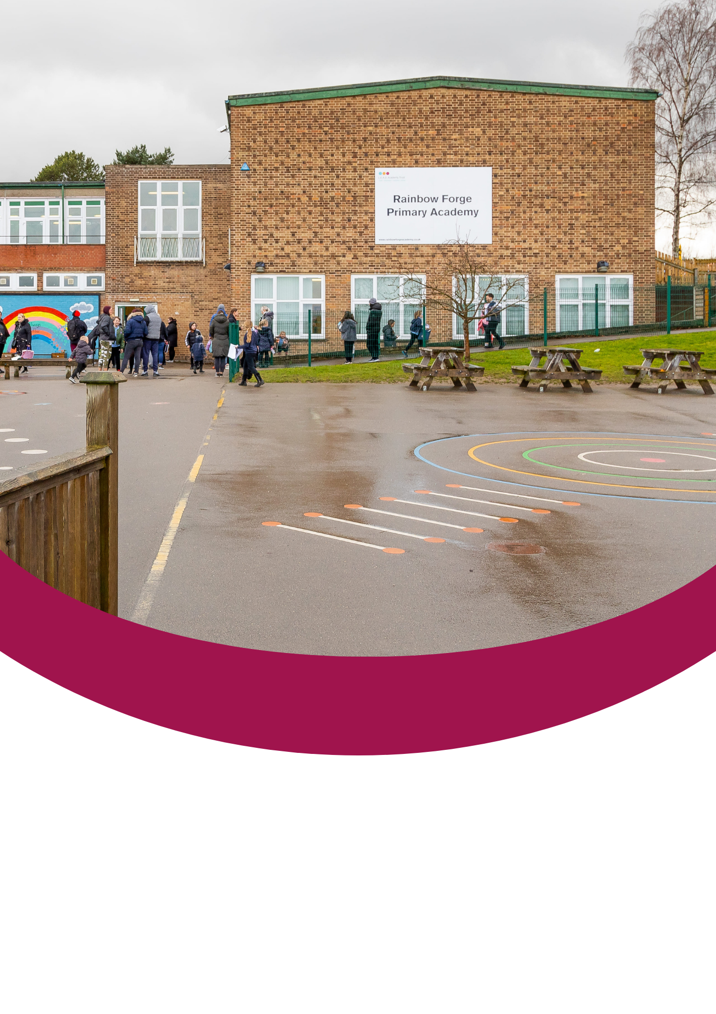
Candidate Information Pack

Level 3 TA


Contents
About the Trust | 1
About us | 2
Our vision and values | 3
Working at Rainbow Forge Primary Academy | 4
Benefits of being part of L.E.A.D. Academy Trust | 5
How to apply | 6
Job description and person specification | 7

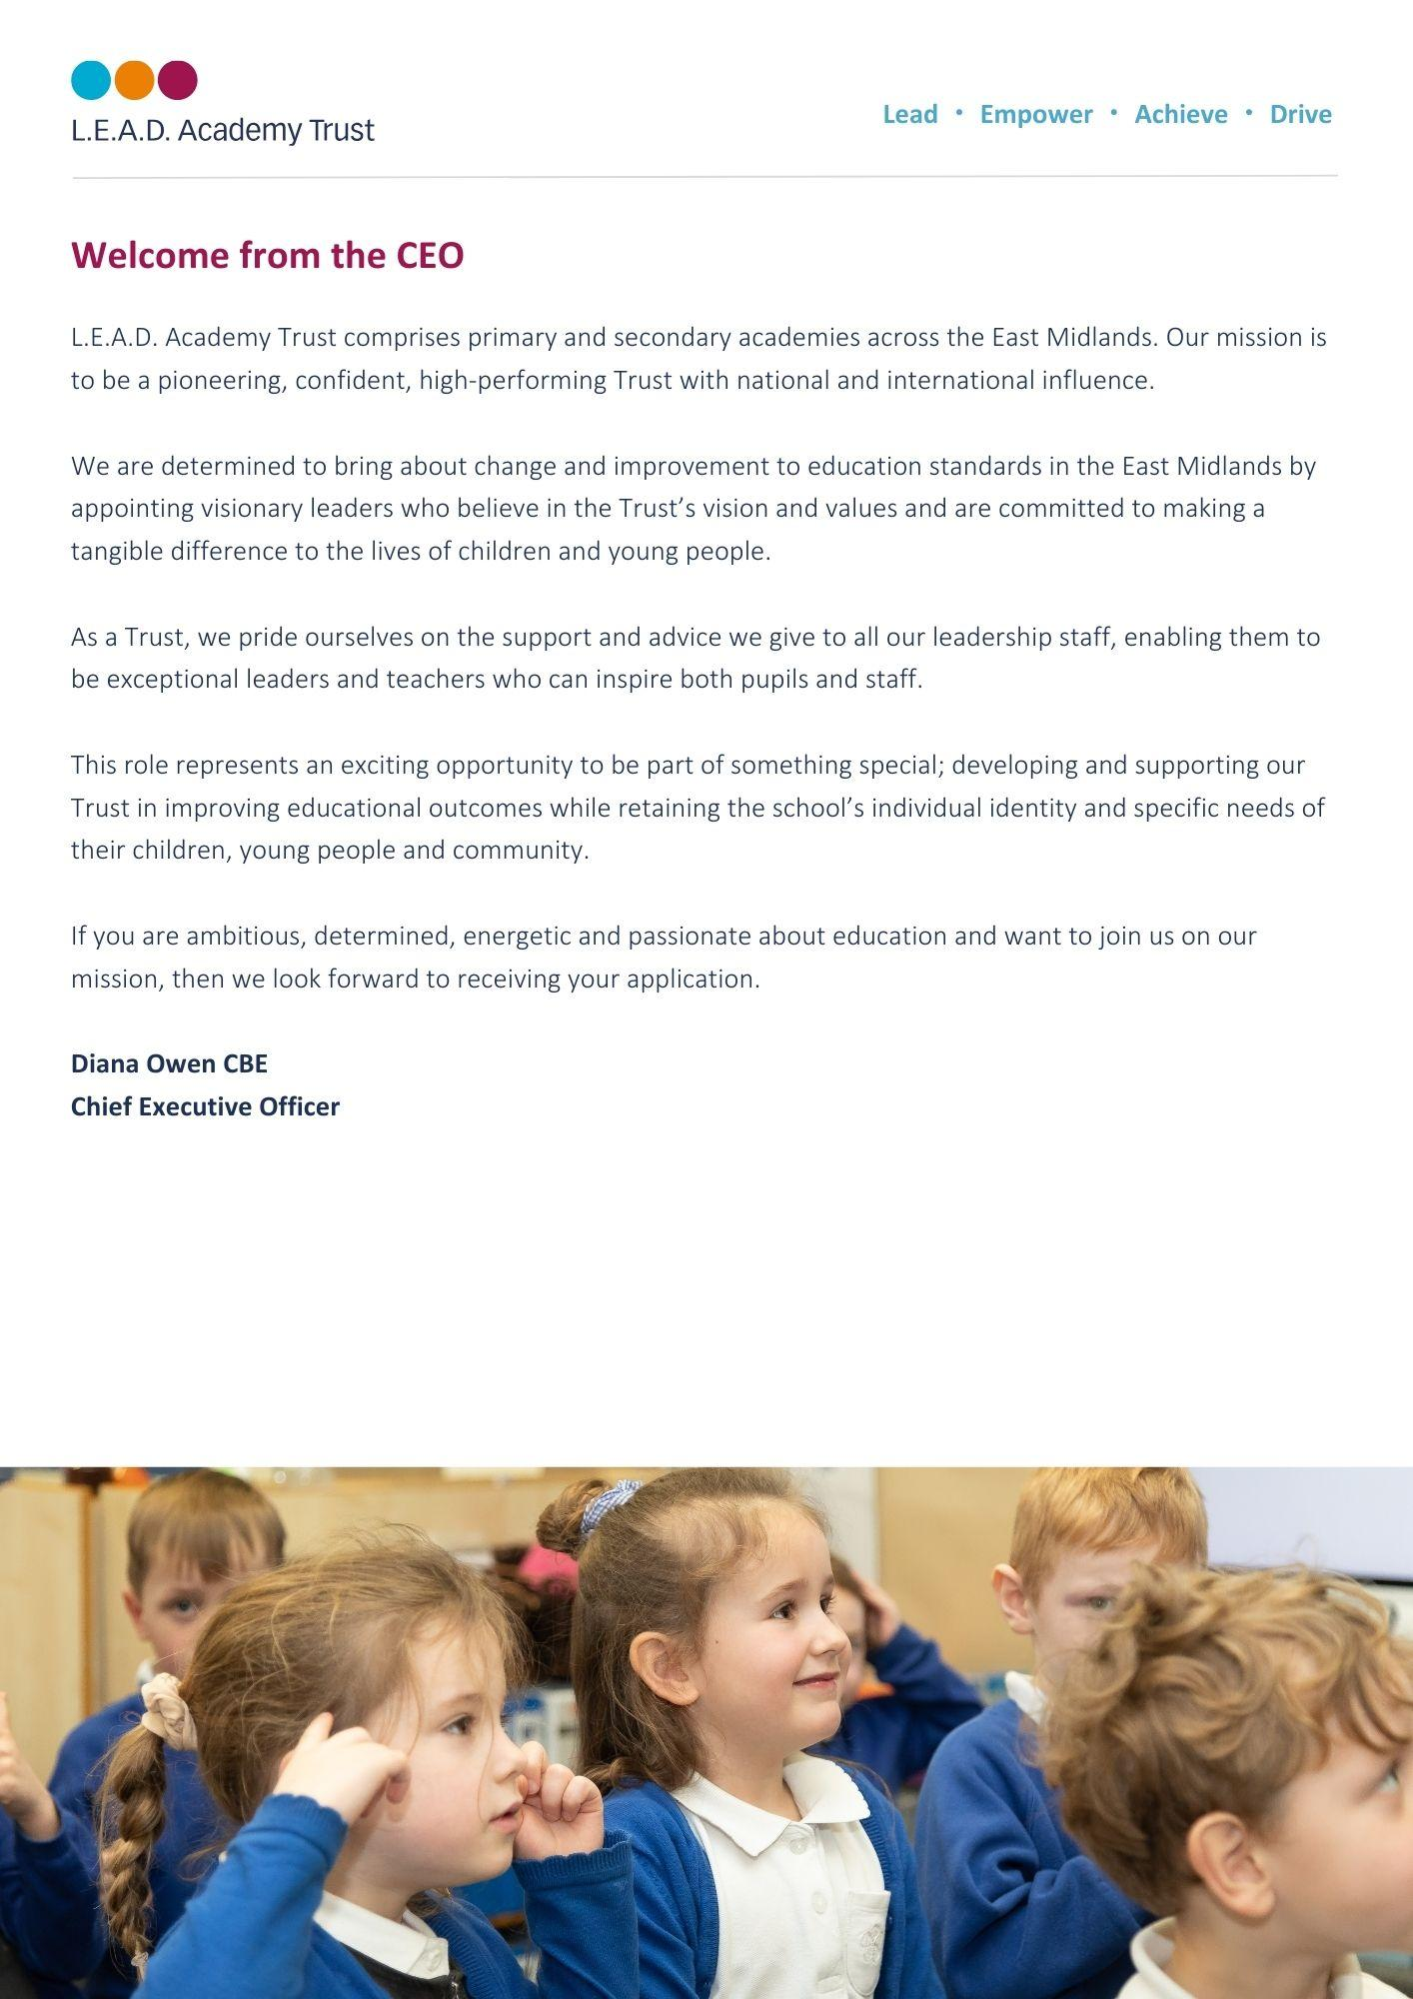
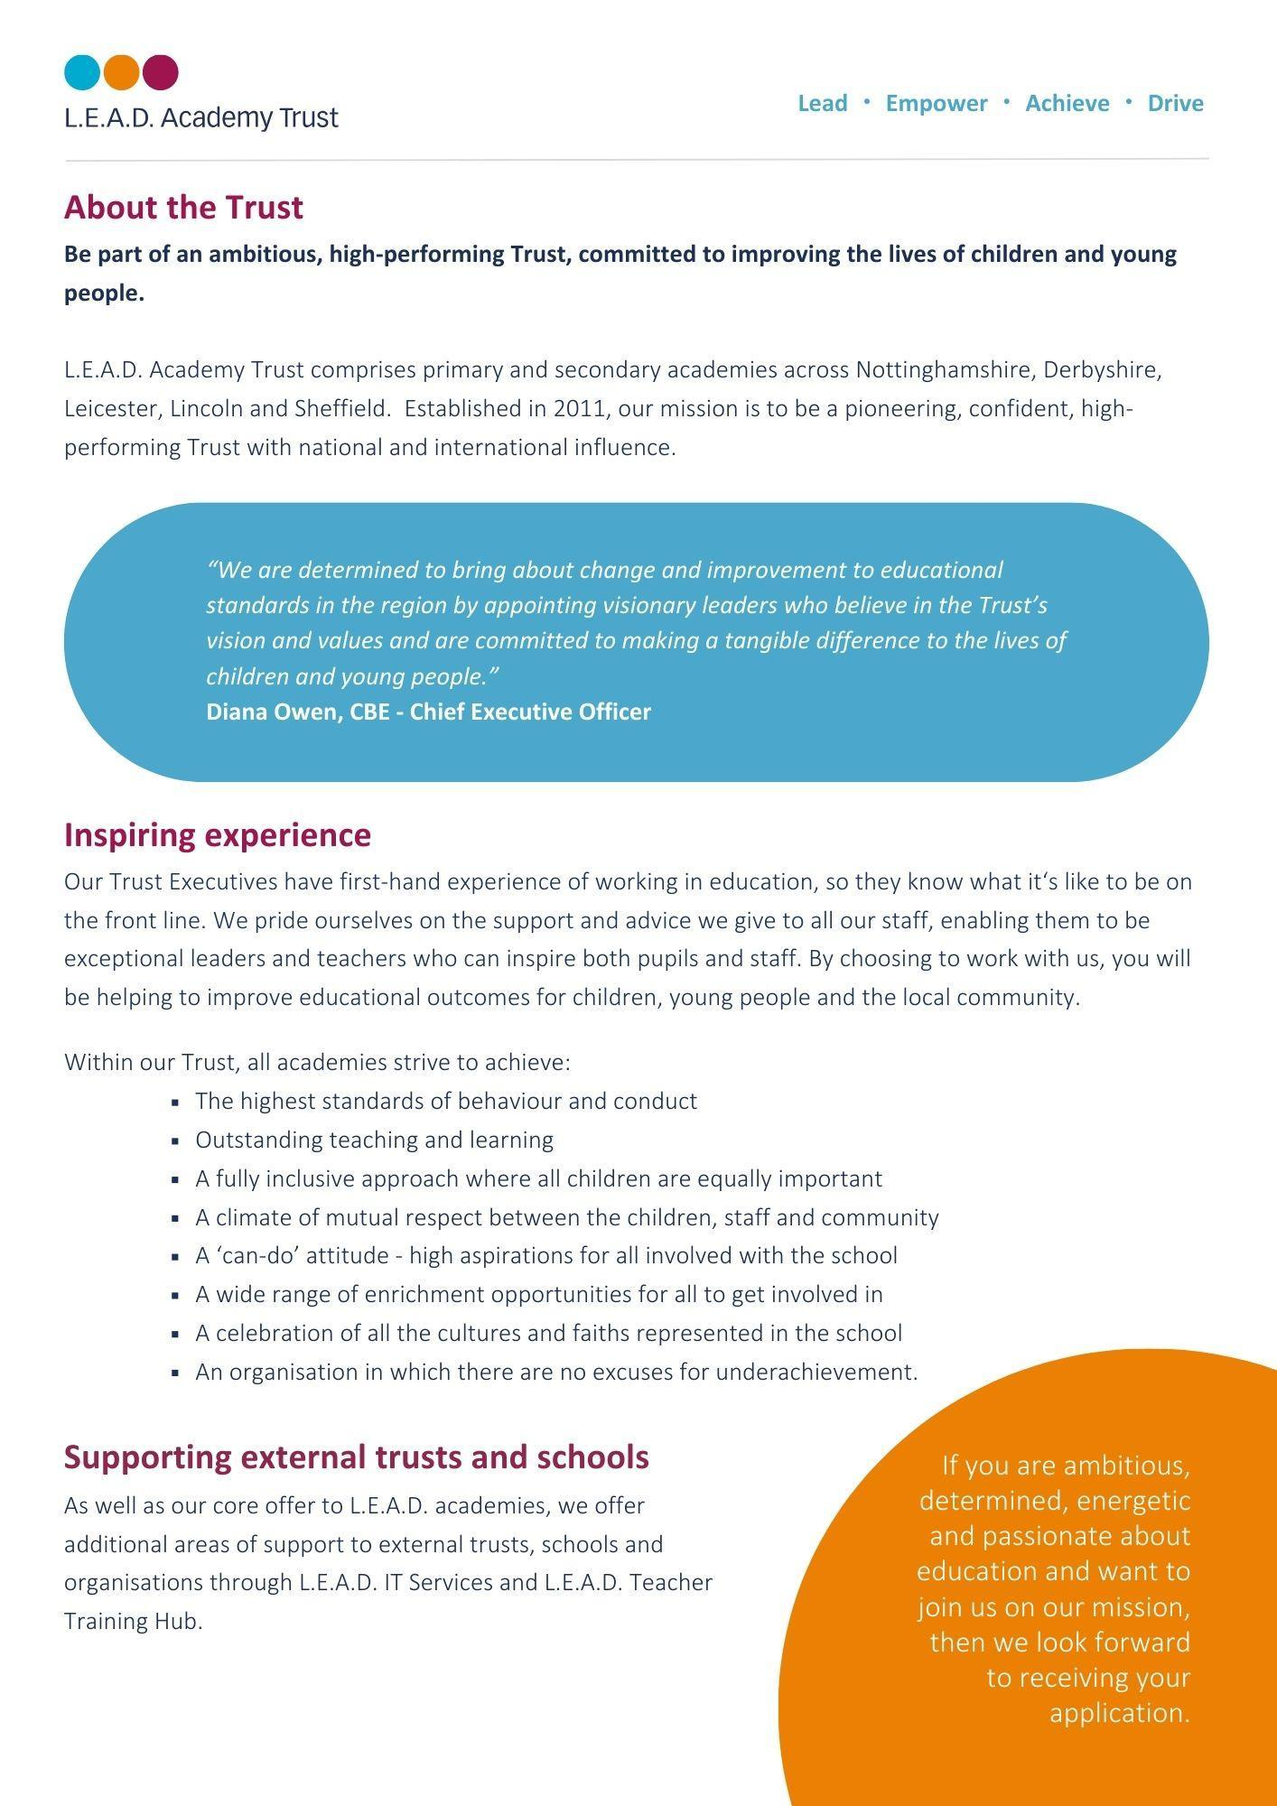
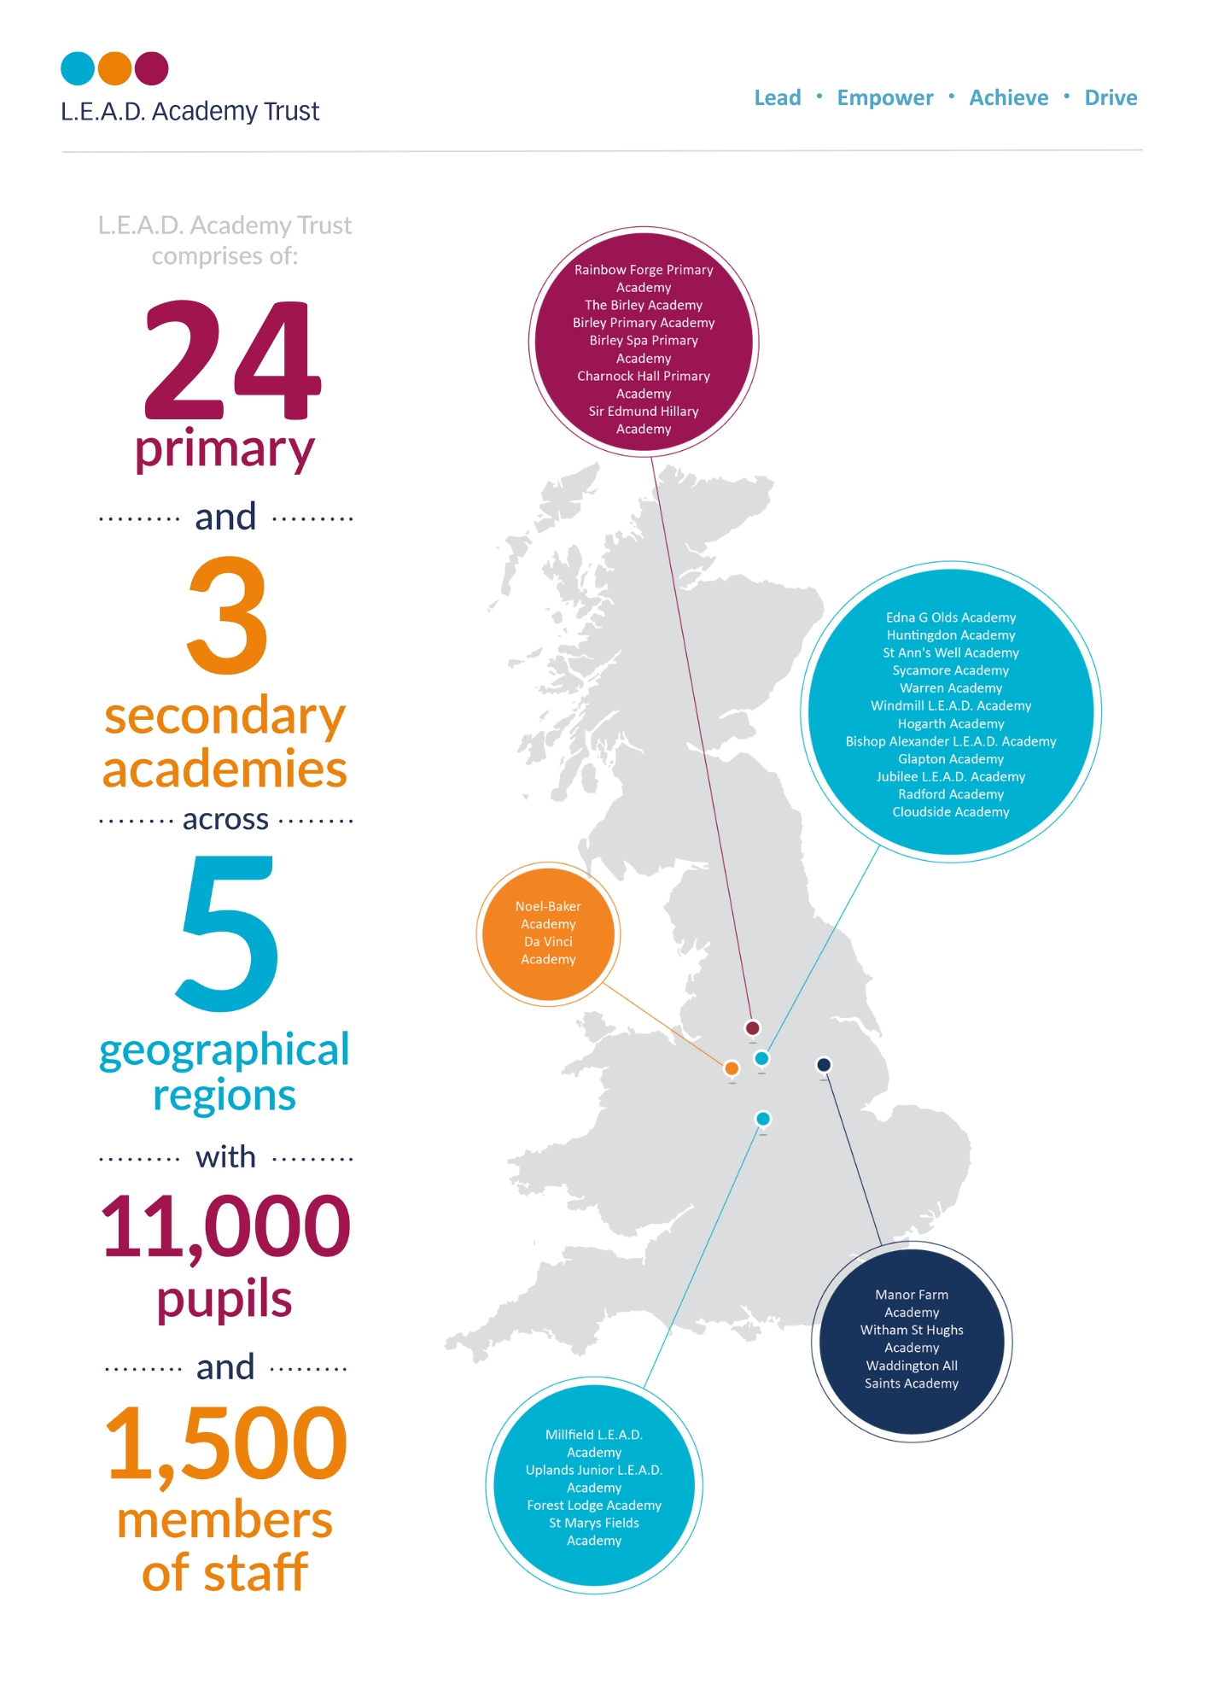

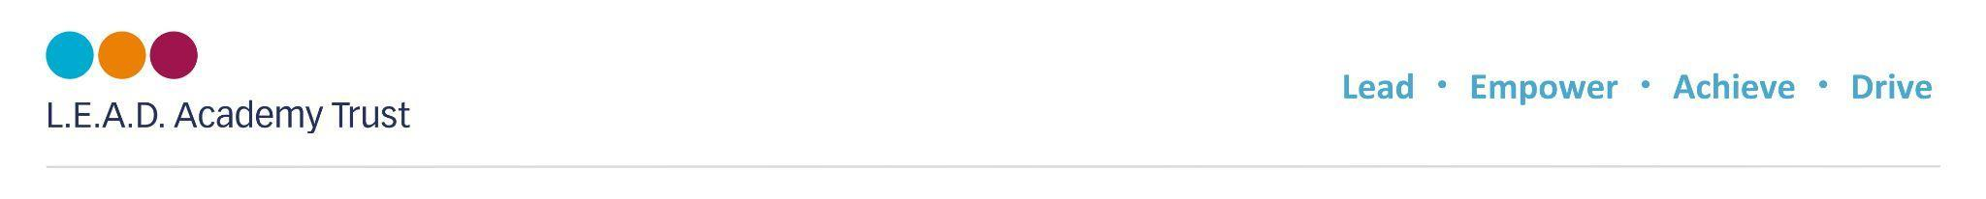
A message from the Headteacher

I am very proud to be the Headteacher at Rainbow Forge Academy and feel privileged to work with our pupils, parents, cares, colleagues and community to be part of the team making Rainbow a fabulous place to learn and work.
I am passionate about creating inclusive classrooms, nurturing the whole-child and working with staff both in school and with colleagues across L.E.A.D Academy Trust to ensure the highest quality education, supporting a love of lifelong learning and where everyone can grow and flourish.
Headteacher – Roberta Reilly
Working at Rainbow Forge Primary Academy
At our Ofsted rated GOOD school, children can begin their journey with us from the age of two and we support our working families by providing wrap around care through breakfast and after school clubs run by our own highly trained, passionate staff.
At Rainbow we pride ourselves on having the very highest of standards of behaviour and attitudes to learning. Our children are our strength, they are proud of their school and enjoy taking an active role within the school community. On visiting Rainbow, you will see happy, friendly children who are eager to learn.
It is our aim to provide our children with the best knowledge available to ensure that they are ready for the next stage of their education.
We are developing a curriculum that ensures the children have a positive attitude to learning and develop the academy values of being Respectful, Honest, Brave, Determined, Kind and Caring.




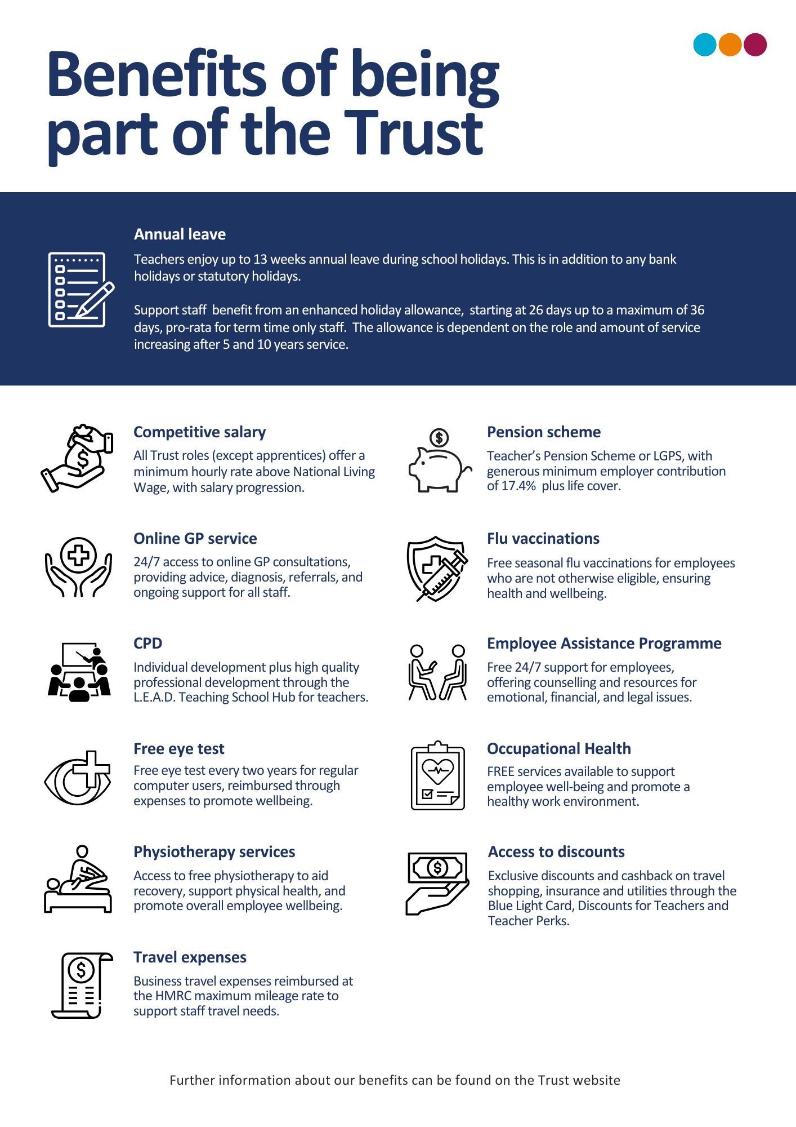


Pupils behave well in lessons and at social times. Pupils know the school rules and respond well to them. As a result, pupils enjoy their lessons- OFSTED Dec 2023

How to apply
Please send a completed application form and covering letter explaining your interest in the role and how you meet the person specification to : Bethanyjames@rainbowforgeacademy.co.uk
CLOSING DATE: 12pm 30th June 2025
INTERVIEWS: We expect interviews to take place Thursday 3rd July 2025

Applications will be reviewed upon receipt, therefore shortlisted candidates may be contacted in advance of the closing date.
L.E.A.D. Academy Trust is committed to safeguarding and promoting the welfare of children and young people and we can expect all staff and volunteers to share this commitment. This post is subject to an enhanced DBS check.
For an informal, confidential discussion about this opportunity, please email: bethanyjames@rainbowforgeacademy.co.uk

Job description
Key responsibilities and accountabilities
L2 Teaching Assistant
Salary: NJC Payscale 12-17 FTE 28,597.75
To work with children as part of a team under the overall direction of the Headteacher who will be responsible for the policy and educational programme and for matters of control and discipline within the National Curriculum Framework.
To foster the participation of pupils in the social and academic processes of the school by recognising individual pupils’ needs and identifying and implementing appropriate responses.
Working independently in accordance within guidelines, to encourage pupils to become more independent learners and help to raise the standard of achievement and attainment for all pupils.
Providing short term cover, without responsibility for planning and assessment (including PPA).
To develop, plan, deliver and review learning activities for individuals and groups of pupils in accordance with best practice and national guidelines.
To carry out specified duties with individuals, groups or classes under the direction of a qualified teacher in accordance with The Education (Specified Work & Registration) (England) Regulations 2003.
To be aware of your responsibility for promoting and safeguarding the welfare of young persons whom you have contact with during the course of your duties.

Main Responsibilities:
Through effective learning strategies, support all pupils to participate in learning activities. This will involve being aware of pupils’ needs, using appropriate equipment and materials and modifying resources as necessary to support pupils to participate and progress.
Contribute to the planning and evaluation of teaching and learning activities by being clear of own role in delivery, sharing realistic ideas, offering constructive suggestions and giving feedback where appropriate
Support pupils by having an awareness of individual needs, learning targets, and the relevant support required to assist pupils’ development, offering encouragement and feedback where appropriate.
Contribute to the implementation of an effective behaviour management strategy, applying it fairly and consistently within clear boundaries and reinforcing positive aspects of behaviour. Provide literacy and numeracy support to individuals and groups to enable them to access the wider curriculum, whilst monitoring progress and dealing with challenges as they arise.

Person specification
The person specification listed below outlines the competences, knowledge and behaviour of candidates who would be suitable for this role. The two right-hand columns provide guidance as to whether these items are essential (E) or desirable (D) criteria.
Qualifications and Attainments | - GCSE pass level or equivalent qualifications in maths/numeracy & English/literacy or significant demonstrable experience in a similar role  - Hold a relevant qualification as listed below | E  E
Skills and  knowledge | - Knowledge and understanding of the statutory framework in subject areas and phases supported  - Knowledge of Teaching Assistants’ contribution to raising standards by the promotion of independent learning  - An appreciation of the National Curriculum and how this is applied to planning, preparation and delivery of learning activities  - Knowledge and understanding of pupil assessment, progress, evaluation and reporting of attainment  - Knowledge of stages of child development and individual needs  - Understanding and awareness of individual needs and ability to adjust communication methods accordingly  - Well-developed communication skills, both orally and in writing  - Ability to establish positive relationships with pupils, families and colleagues  - Ability to assist with transition between phases both inside and outside school  - Ability to plan, prepare and deliver a lesson under direction from the teacher  - Ability to implement programmes planned with colleagues and/or other professionals  - Knowledge of appropriate behaviour management practices  - Knowledge of Health and Safety policies and procedures that contribute to the maintenance of pupil safety and security  - Knowledge of safeguarding procedures and protocols  - Ability to organise classroom resources and assist with the maintenance of pupil records | E  E  E  E  E  E  E  E  E  E  E  E  E  E | D
Experience | - Experience of working within an education setting or equivalent  - Direct experience of working with pupils to raise attainment through personal intervention  - Proven experience of working with children and young people, including children with individual needs and from a range of backgrounds  - Innovative use of resources and materials including ICT software and equipment  - Experience of planning and delivering learning activities for group and individual need  - Understanding the role of parents/carers and the wider community in education  - Experience of working with children or young people with SEND | E  E  E  E  E  E  E
Personal Attributes | - Have an openness to learning and change  - Have a positive attitude to personal development and training  - Be able to work in ways that promote equality of opportunity, participation, diversity and responsibility | E  E  E
Additional Requirements | - This role is subject to an enhanced DBS  - May be required to work out of school hours to support the Academy | E  E



Email address:
enquiries@rainbowforgeacademy.co.uk
Phone number:
0114 2487342

