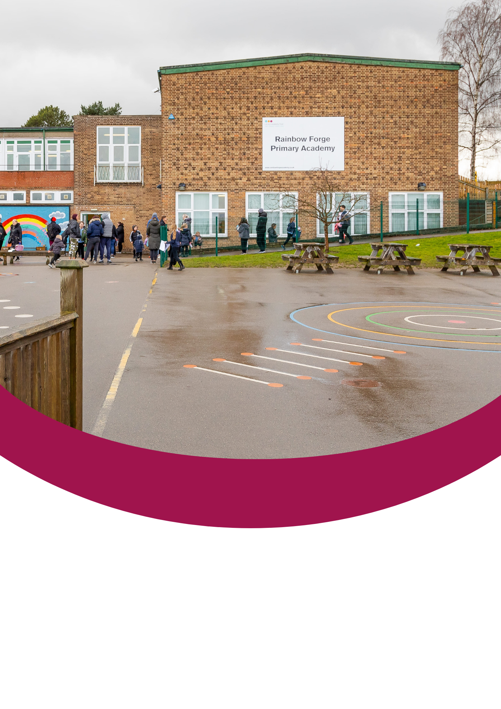
Candidate Information Pack

Level 3 Teaching Assistant (Maternity Cover)


Contents
About the Trust | 1
About us | 2
Our vision and values | 3
Working at Rainbow Forge Primary Academy | 4
Benefits of being part of L.E.A.D. Academy Trust | 5
How to apply | 6
Job description and person specification | 7

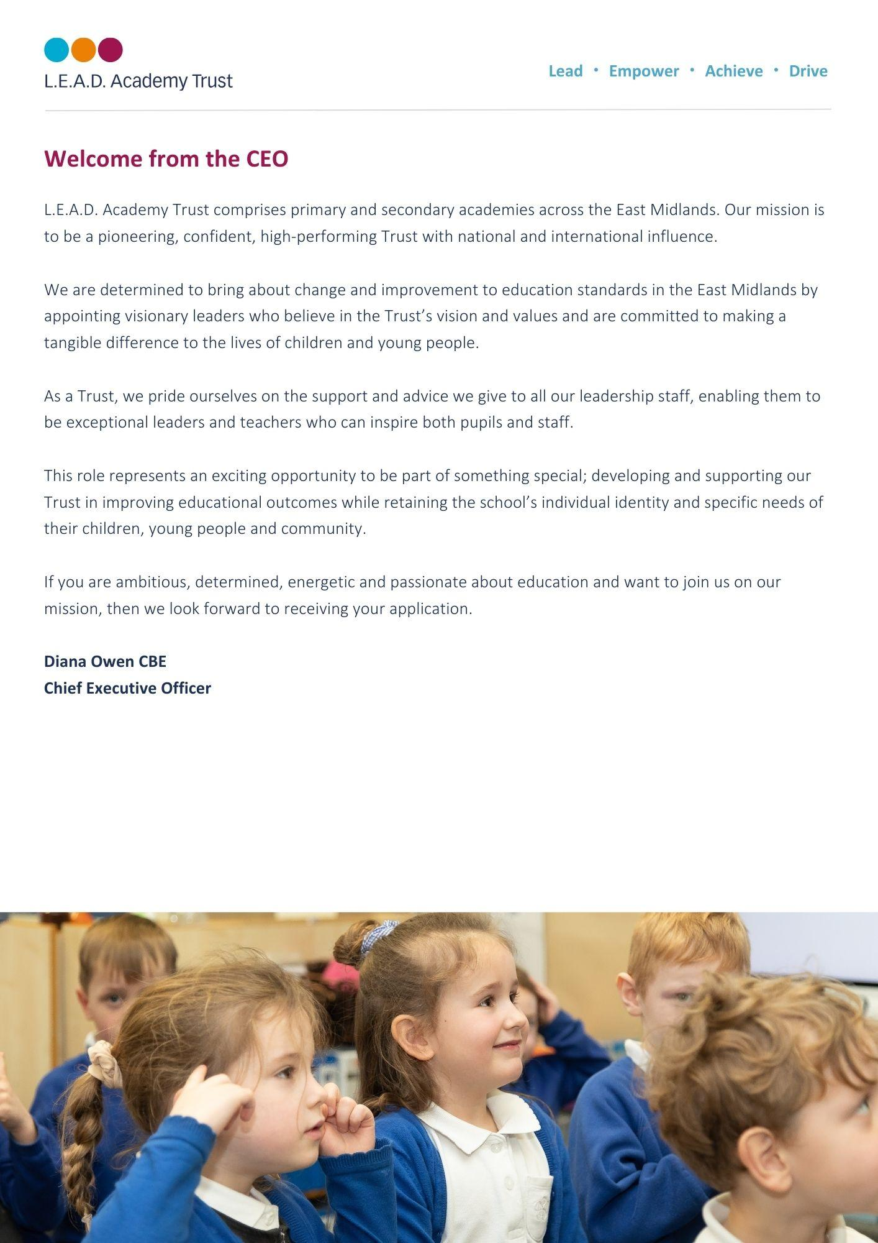
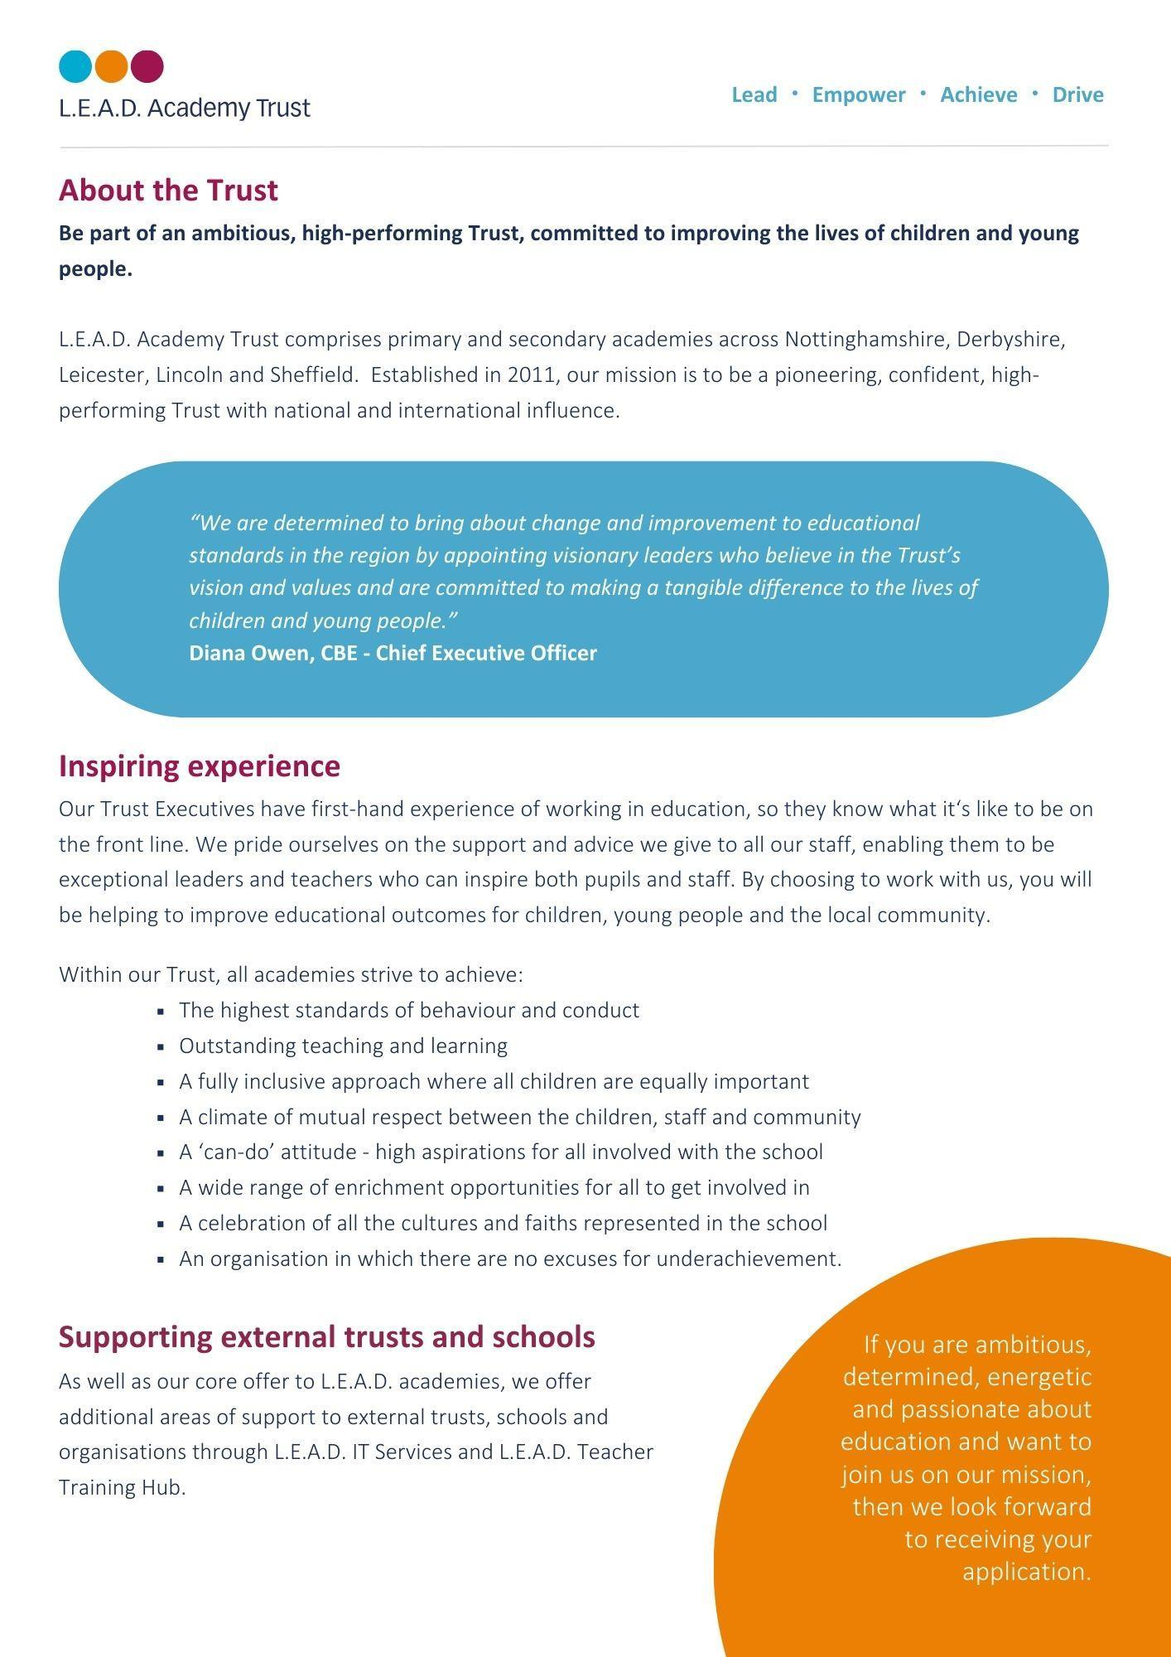
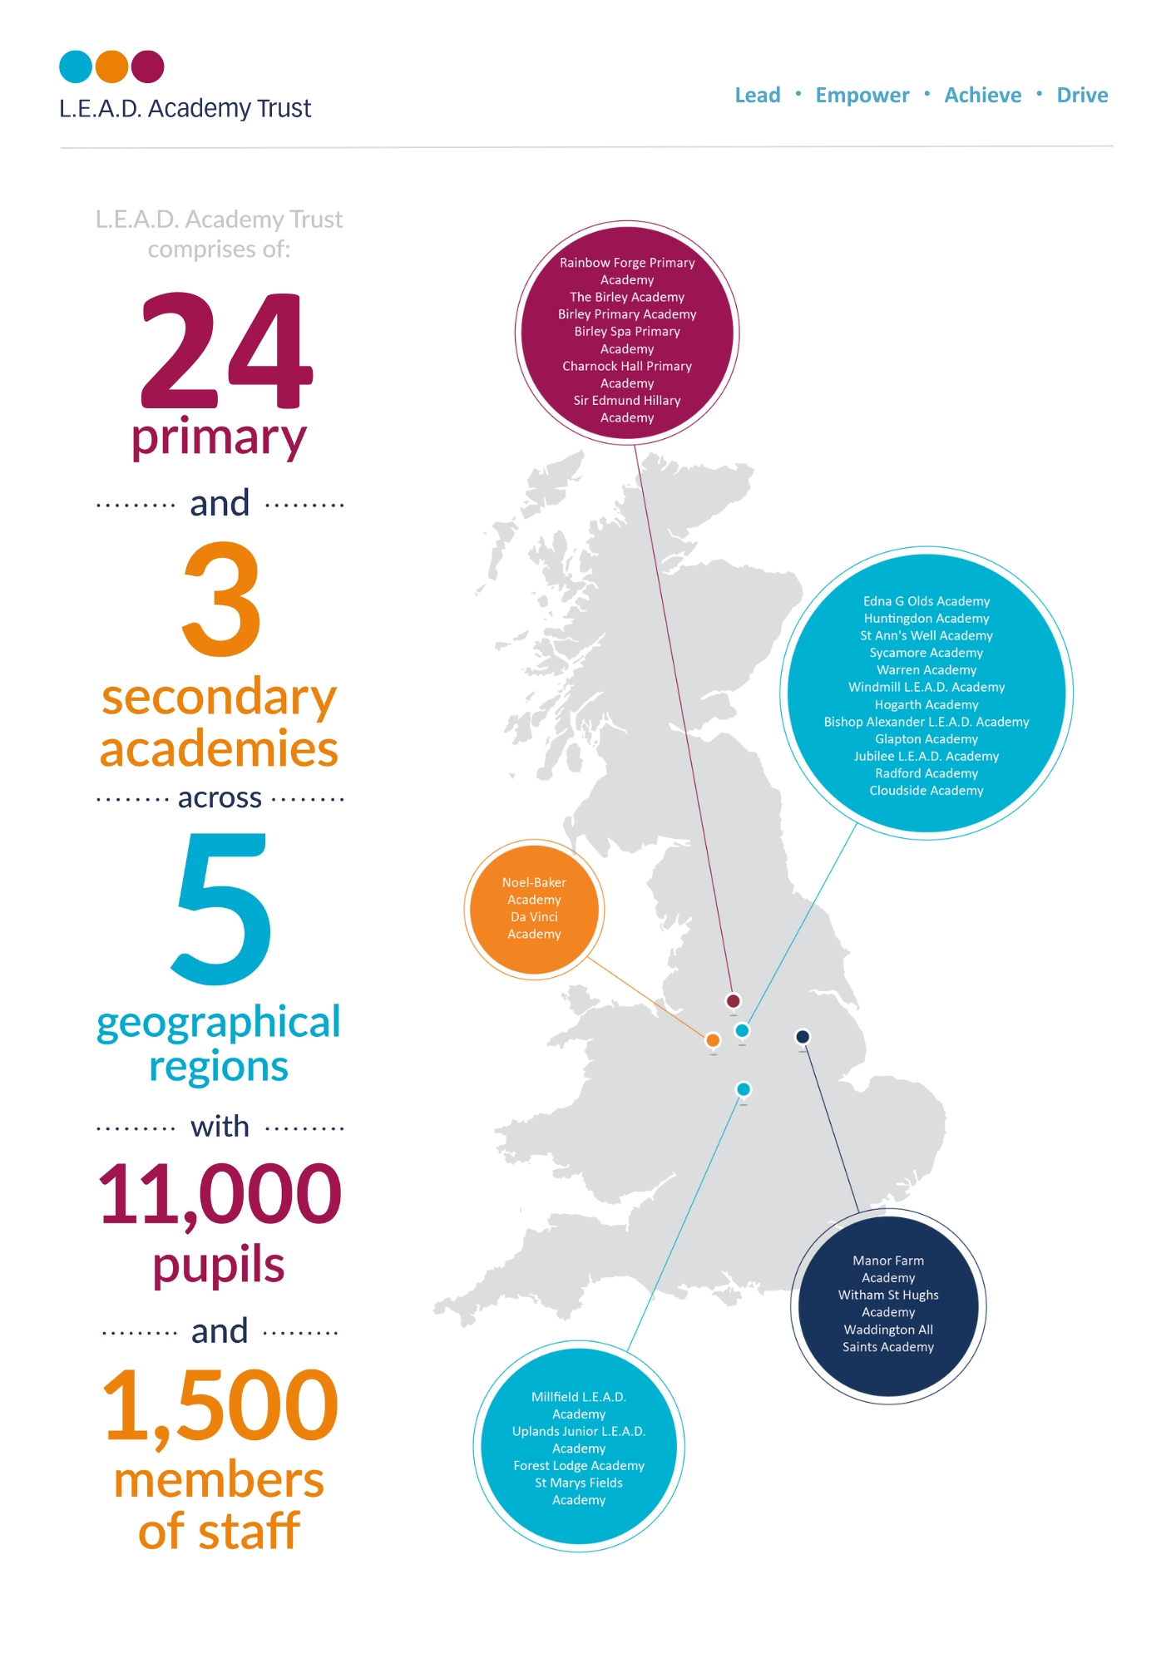

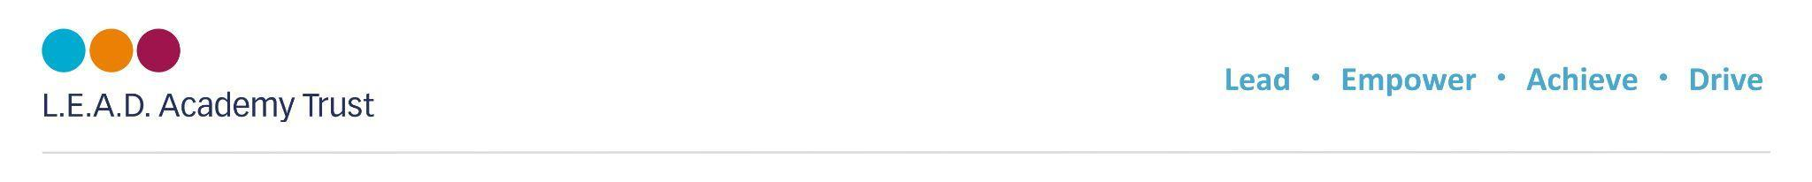
A Message from the Headteacher

I am very proud to be the Headteacher at Rainbow Forge Academy and feel privileged to work with our pupils, parents, cares, colleagues and community to be part of the team making Rainbow a fabulous place to learn and work.
I am passionate about creating inclusive classrooms, nurturing the whole-child and working with staff both in school and with colleagues across L.E.A.D Academy Trust to ensure the highest quality education, supporting a love of lifelong learning and where everyone can grow and flourish.
Roberta Reilly
About Rainbow Forge Primary Academy
At our Ofsted rated GOOD school, children can begin their journey with us from the age of two and we support our working families by providing wrap around care through breakfast and after school clubs run by our own highly trained, passionate staff.
At Rainbow we pride ourselves on having the very highest of standards of behaviour and attitudes to learning. Our children are our strength, they are proud of their school and enjoy taking an active role within the school community. On visiting Rainbow, you will see happy, friendly children who are eager to learn.
It is our aim to provide our children with the best knowledge available to ensure that they are ready for the next stage of their education.
We are developing a curriculum that ensures the children have a positive attitude to learning and develop the academy values of being Respectful, Honest, Brave, Determined, Kind and Caring.

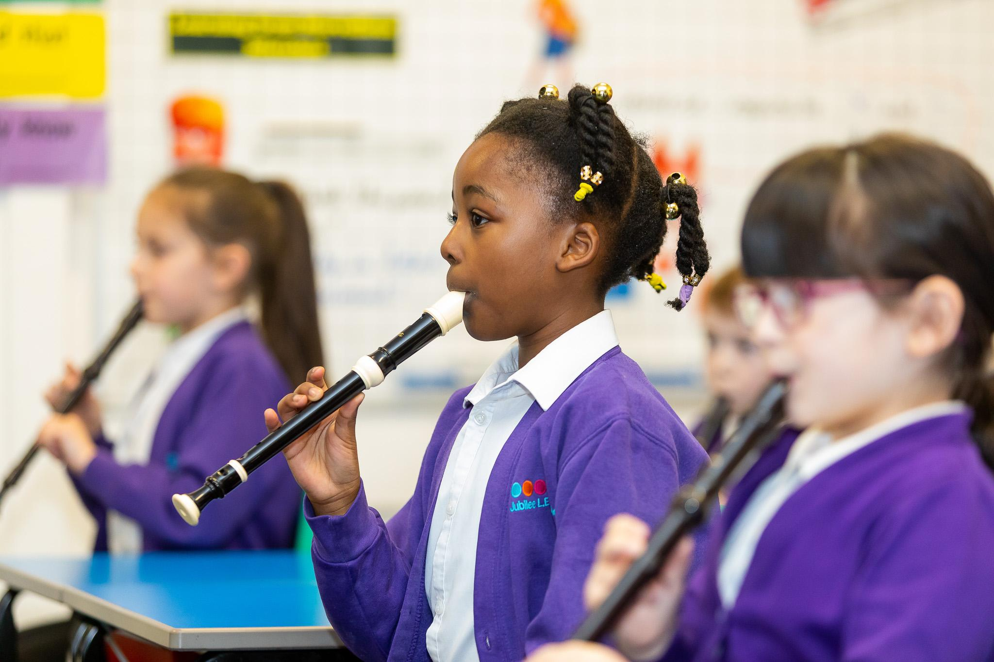



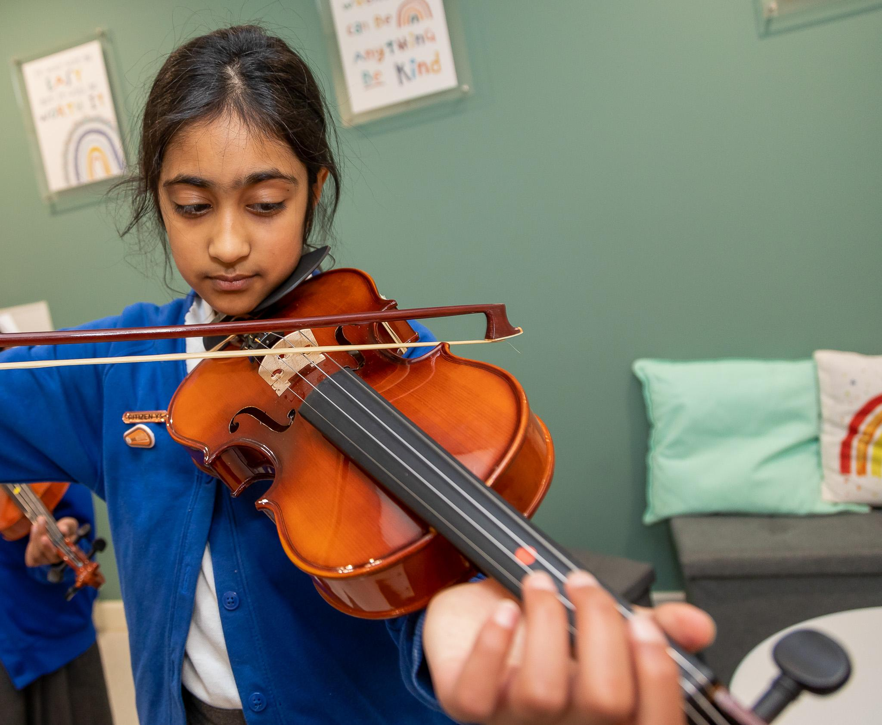

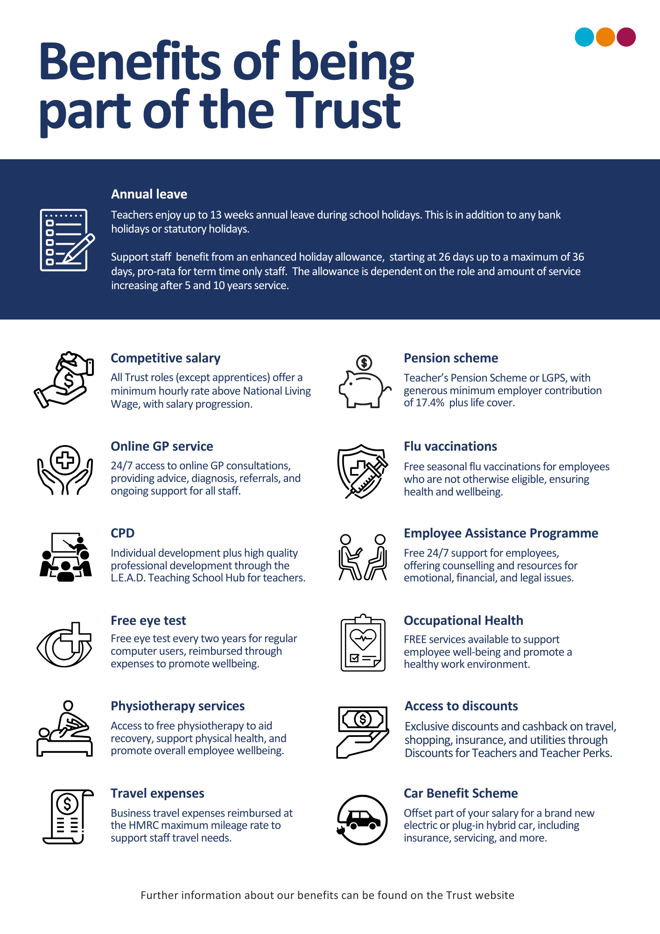


Pupils behave well in lessons and at social times. Pupils know the school rules and respond well to them. As a result, pupils enjoy their lessons- OFSTED Dec 2023

How to apply
Please send a completed application form and covering letter explaining your interest in the role and how you meet the person specification to: bethanyjames@rainbowforgeacademy.co.uk
CLOSING DATE: Monday 6th January 2025 9am
INTERVIEWS: TBC

Applications will be reviewed upon receipt, therefore shortlisted candidates may be contacted in advance of the closing date.
L.E.A.D. Academy Trust is committed to safeguarding and promoting the welfare of children and young people and we can expect all staff and volunteers to share this commitment. This post is subject to an enhanced DBS check.
For an informal, confidential discussion about this opportunity, please email: bethanyjames@rainbowforgeacademy.co.uk

Job description
Key responsibilities and accountabilities
Level 3 Teaching Assistant
Salary: FTE £27711
Main Responsibilities:
Job purpose:

- To work with children as part of a team under the overall direction of the Headteacher who will be responsible for the policy and educational programme and for matters of control and discipline within the National Curriculum Framework.
- To foster the participation of pupils in the social and academic processes of the school by recognising individual pupils’ needs and identifying and implementing appropriate responses.
- Working independently in accordance within guidelines, to encourage pupils to become more independent learners and help to raise the standard of achievement and attainment for all pupils.
- Providing short term cover, without responsibility for planning and assessment (including PPA).
- To develop, plan, deliver and review learning activities for individuals and groups of pupils in accordance with best practice and national guidelines.
- To carry out specified duties with individuals, groups or classes under the direction of a qualified teacher in accordance with The Education (Specified Work & Registration) (England) Regulations 2003.
- To be aware of your responsibility for promoting and safeguarding the welfare of young persons whom you have contact with during the course of your duties.

Duties and Responsibilities:

Key Duties
- Through effective learning strategies, support all pupils to participate in learning activities. This will involve being aware of pupils’ needs, using appropriate equipment and materials and modifying resources as necessary to support pupils to participate and progress.
- Contribute to the planning and evaluation of teaching and learning activities by being clear of own role in delivery, sharing realistic ideas, offering constructive suggestions and giving feedback where appropriate
- Support pupils by having an awareness of individual needs, learning targets, and the relevant support required to assist pupils’ development, offering encouragement and feedback where appropriate.
- Contribute to the implementation of an effective behaviour management strategy, applying it fairly and consistently within clear boundaries and reinforcing positive aspects of behaviour.
Provide literacy and numeracy support to individuals and groups to enable them to access the wider curriculum, whilst monitoring progress and dealing with challenges as they arise.

Specified Work
- Carry out specified work in order to assist or support the work of a qualified teacher. This is an on-going and regular requirement of the post and is an integral element of the role at this level.

Including:
- Collaborative planning and preparing lessons;
- Delivering lessons to group of pupils;
- Assessing the development, progress and attainment of pupils;
- Feedback on the development, progress and attainment of pupils.

Support for the Pupil
- Support learning activities for all pupils, being aware of stages of development, individual needs and giving positive encouragement and feedback to ensure pupils are reaching their full potential. The learning activities may be for individual pupils, groups of pupils, or the whole class and may be delivered in the absence of the teacher.
- Give care and support for pupils by providing a safe and secure environment, responding to accidents, emergencies and following procedures where appropriate.
- Contribute to the safeguarding of all pupils by having an awareness of signs of abuse, an understanding of relevant procedure and protocol and ensuring any concerns are addressed in a calm and sensitive manner.
- Establish and maintain positive relationships with pupils by communicating effectively, allowing them to feel valued and listened to, encouraging questions and ideas.
- Support children and young people through transitions that occur in their lives, enabling them to manage them in a positive manner.
- Contribute to the personal and intimate care of pupils.
- Support pupils with behaviour, emotional and social development needs and report any issues to the appropriate senior member of staff.
- Provide support to pupils where English is an additional language.
- Support learning activities for high achieving pupils.
- Support pupils in a specialist area e.g. ICT, Literacy, Numeracy.
- To support children and young people with SEND, supporting them to actively participate in learning activities. To liaise with parent/carers/outside agencies as required.

Support for the Teacher
- To assist with writing and monitoring pupil plans reviewing and implementing interventions enabling pupils to understand and meet their targets.
- Support with the delivery of learning activities in the absence of the teacher, e.g. when providing cover supervision or working with pupils outside of the classroom.
- Contribute to maintaining accurate pupil records, following relevant procedure and ensuring confidentiality at all times.
- Working alongside the class teacher, ensure the learning environment, learning resources and materials are ready for use in activities whilst recognising and minimising potential hazards and making adjustments where necessary.
- Develop positive relationships with families, taking a partnership approach so that support is provided both at the school and at home and sharing information where appropriate.
- Escort and supervise pupils on educational visits and out of school activities.

Support for the Curriculum

- Support pupils in activities to develop their literacy and numeracy skills by having an awareness of individual needs, learning targets, and the relevant support required to assist pupils’ development, offering encouragement and feedback where appropriate.
- Prepare and effectively use ICT within the classroom environment to support and promote pupils’ learning in ways that are stimulating and enjoyable for pupils according to age, needs and abilities.

Support for the School

- Develop and maintain effective working relationships with other practitioners, drawing on their strengths and expertise in order to best support teaching and learning.
- Support children and young people through transitions that occur in their lives, enabling them to manage them in a positive manner.
- Willingness to keep up to date with professional practice by maintaining an up-to-date understanding of the requirements of the role and individual responsibilities.
- Contribute to maintaining accurate pupil records following relevant procedure and ensuring confidentiality at all times.

Influencing and Managing Relationships:

- Headteacher
- L.E.A.D. Central Support
- External agencies
- Parents and carers
- Governors
- Senior Leadership Team
- Staff
Person specification
This job description lists the competencies expected of an experienced/fully trained post-holder. The two right hand columns provide guidance for the appointment of new staff. (E = Essential criteria, D + Desirable criteria)
 |  | E | D
Qualifications and Attainments | - GCSE pass level or equivalent qualifications in maths/numeracy & English/literacy or significant demonstrable experience in a similar role  - Hold a relevant qualification as listed below | E  E
Skills and  knowledge | - Knowledge and understanding of the statutory framework in subject areas and phases supported  - Knowledge of Teaching Assistants’ contribution to raising standards by the promotion of independent learning  - An appreciation of the National Curriculum and how this is applied to planning, preparation and delivery of learning activities  - Knowledge and understanding of pupil assessment, progress, evaluation and reporting of attainment  - Knowledge of stages of child development and individual needs  - Understanding and awareness of individual needs and ability to adjust communication methods accordingly  - Well-developed communication skills, both orally and in writing  - Ability to establish positive relationships with pupils, families and colleagues  - Ability to assist with transition between phases both inside and outside school  - Ability to plan, prepare and deliver a lesson under direction from the teacher  - Ability to implement programmes planned with colleagues and/or other professionals  - Knowledge of appropriate behaviour management practices  - Knowledge of Health and Safety policies and procedures that contribute to the maintenance of pupil safety and security  - Knowledge of safeguarding procedures and protocols  - Ability to organise classroom resources and assist with the maintenance of pupil records | E  E  E  E  E  E  E  E  E  E  E  E  E  E | D
Experience | - Experience of working within an education setting or equivalent  - Direct experience of working with pupils to raise attainment through personal intervention  - Proven experience of working with children and young people, including children with individual needs and from a range of backgrounds  - Innovative use of resources and materials including ICT software and equipment  - Experience of planning and delivering learning activities for group and individual need  - Understanding the role of parents/carers and the wider community in education  - Experience of working with children or young people with SEND | E  E  E  E  E  E  E
Personal Attributes | - Have an openness to learning and change  - Have a positive attitude to personal development and training  - Be able to work in ways that promote equality of opportunity, participation, diversity and responsibility | E  E  E
Additional Requirements | - This role is subject to an enhanced DBS  - May be required to work out of school hours to support the Academy | E  E

Teaching Assistant Qualifications

Level 3 Certificate and Diploma in Supporting Teaching and Learning (STL)
Level 3 NVQ Supporting Teaching and Learning (STL)
Level 3 NVQ Childcare Learning and Development (CCLD)
Level 3 CACHE Diploma in Childcare and Education
Open University Certificate in Early Years Practice
Relevant Foundation Degree (relating to childcare and education)
QTS
Relevant degree in education studies accompanied by demonstrated practical experience as detailed in the person specification above.
National Nursery Nursing Board Award (NNEB)
BTEC National Learning Support
Children’s Care and Education Diploma (CCE)
NVQ Level 3 in Early Years and Childcare
NVQ Level 3 Caring for Children and Young People
Open University Specialist Teaching Assistant Certificate (STAC)
Specialist Teaching Assistant Award (STA)
City and Guilds Certificate in Learning Support combined with NCFE
3563 Special Needs Assistant Qualification
NVQ3 Teaching Assistant



Email address:
bethanyjames@rainbowforegacademy.co.uk
Phone number:
0114 2487342

